JUnit Testing Exercises

# **Exercise 1: Setting Up JUnit**

Scenario:

You need to set up JUnit in your Java project to start writing unit tests.

Steps:

1. Create a new Java project in your IDE (e.g., IntelliJ IDEA, Eclipse).

2. Add JUnit dependency to your project. If you are using Maven, add the following to your

pom.xml:

<dependency>

<groupId>junit</groupId>

<artifactId>junit</artifactId>

<version>4.13.2</version>

<scope>test</scope>

</dependency>

3. Create a new test class in your project.

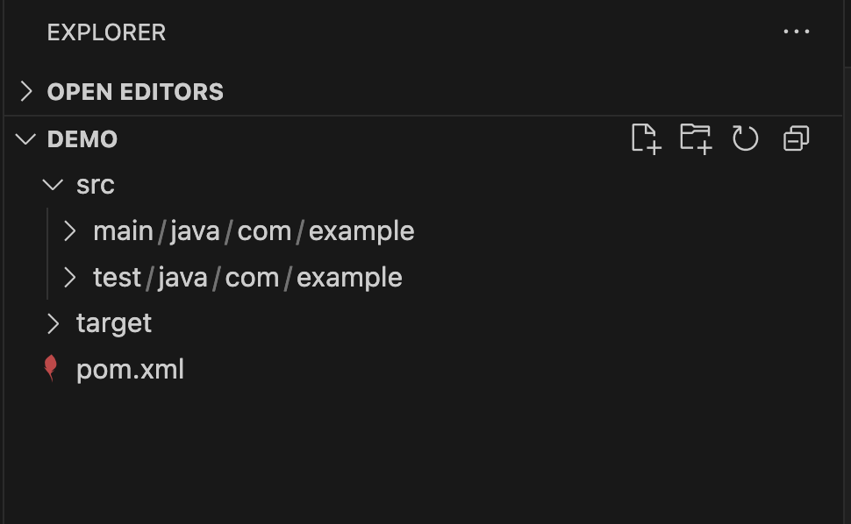

# **Exercise 3: Assertions in JUnit**

Scenario:

You need to use different assertions in JUnit to validate your test results.

Steps:1. Write tests using various JUnit assertions.

Solution Code:

public class AssertionsTest {

@Test

public void testAssertions() {

// Assert equals

assertEquals(5, 2 + 3);

// Assert true

assertTrue(5 > 3);

// Assert false

assertFalse(5 < 3);

// Assert null

assertNull(null);

// Assert not null

assertNotNull(new Object());

}

}

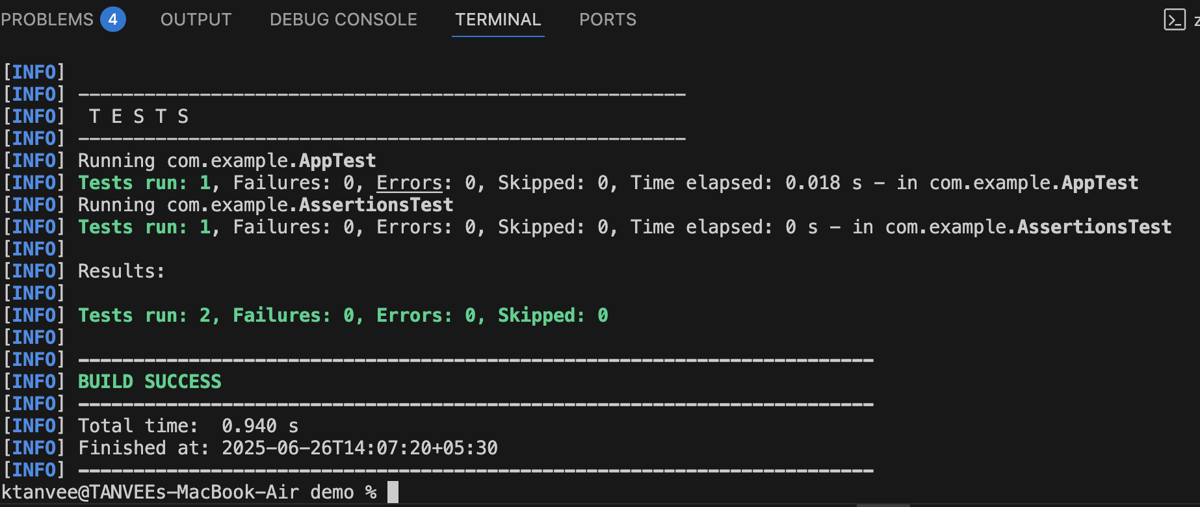

**Exercise 4: Arrange-Act-Assert (AAA) Pattern, Test Fixtures, Setup and**

**Teardown Methods in JUnit**

Scenario:

You need to organize your tests using the Arrange-Act-Assert (AAA) pattern and use setup

and teardown methods.

Steps:

1. Write tests using the AAA pattern.

2. Use @Before and @After annotations for setup and teardown methods.

**Code:**

package com.example;

import org.junit.After;

import org.junit.Before;

import org.junit.Test;

import static org.junit.Assert.*;

public class CalculatorTest {

private Calculator calc;

@Before

public void setUp() {

// Arrange

calc = new Calculator();

System.out.println("Setup complete");

}

@Test

public void testAddition() {

// Act

int result = calc.add(2, 3);

// Assert

assertEquals(5, result);

}

@After

public void tearDown() {

calc = null;

System.out.println("Teardown complete");

}

}

